Overview
The bidirectional syncing of information from XSIAM to ServiceNow is of critical importance to many security operations teams. Many teams leverage ServiceNow case management to notify external stakeholders of declared incidents, track their impact over time, create dashboards, and ultimately request remediation through various support teams.

Problem Statement
Prior to the creation of XSIAM, many security teams leveraged XSOAR to handle the day to day security operations. “Mirroring” was a capability which XSOAR leveraged in order to handle the syncing of incidents and their creation between XSOAR and Servicenow. This “mirroring” capability leveraged incoming and outgoing mappers to determine which fields to sync and in which system the “source of truth” ultimately resided for each individual field.

There were a few challenges with “Mirroring” in general.
- API calls were made every minute for all incidents marked for mirroring, regardless of if a change occurred in either system. This caused a high number of API calls to be used and potential problems with volume of calls to SaaS systems.
- Each field could only be synced in one direction. This made it confusing as the direction was determined by which system modified the field first. ie. fields in a ServiceNow incident might be originating in either ServiceNow or XSIAM from a synching perspective.
- Configuration was often challenging since mappers required special,particular fields to be mapped in order to function correctly.

Solution Statement
The flow diagram for the solution can be found below.

Two playbooks are used to showcase the creation and updating of incidents in ServiceNow from alerts which are created in a single XSIAM incident.

A slightly modified version of the ServiceNow integration is used to track updates in ServiceNow via the occurred time field. In this way API calls are conserved since only when an update occurs it is then fetched into XSIAM. Additionally either system, XSIAM or ServiceNow, can update fields and have the subsequent changes synced between each system.

Layout dynamic sections are used to show the ServiceNow fields in XSIAM. Layout buttons on the incident are used to trigger ad hoc syncing in either direction.

Content will eventually be provided as a part of the OOTB integration.
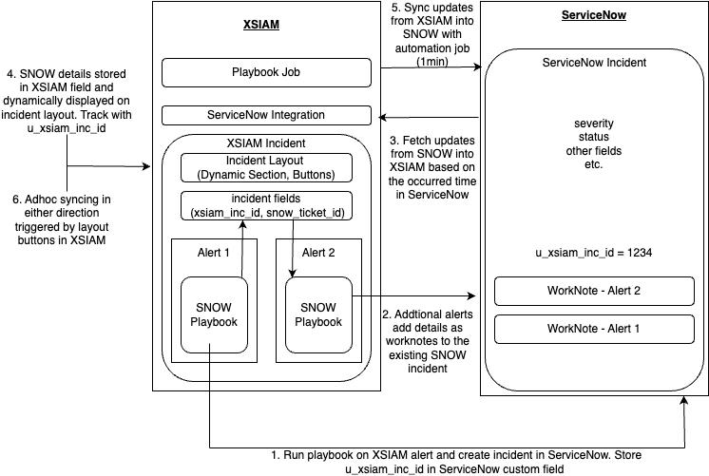

Installation
- Create an incident field in ServiceNow “xsiam inc id”
- Create two incident level fields in XSIAM
  - ServiceNow Ticket Details (Type: Markdown)
  - ServiceNow Ticket ID (Type: Short Text)
- Upload the “ServiceNow v2 - XSIAM Mirroring integration”

This is a slightly modified version of the out of the box integration which is designed to handle updates made from ServiceNow incidents into XSIAM automatically.

The “Connect” section of the integration should be filled out as usual with the service url, username, and password.

Under the “Collect” section of the integration define the following parameters

Parameter | Suggested Value
Alert type | ServiceNow Ticket
Incoming Mapper | ServiceNow - Incoming Mapper
The query to use when fetching incidents (optional) | Leave this blank if you also want closed cases in Servicenow to be closed in XSIAM as well
Timestamp field to filter by… | sys_updated_on
XSIAM API Server URL | https://api-<tenantinfo>.paloaltonetworks.com
XSIAM API Key ID | Standard API key ID
XSIAM API Key | Standard API key
Use Display Value (optional) | Check this box if desired to fetch work notes and comments as well
Instance Date Format (optional) | Required if Display Value is set and work notes are being pulled

The rest of the parameters can be left as their default values or as required by the standard ServiceNow v2 integration.

- Upload Example playbooks into the XSIAM tenant
  - Test - Malicious File Action Playbook
  - Core - Create ServiceNow Ticket for XSIAM Incident from Alert

Creation of ServiceNow tickets for each incident created in XSIAM can be done at the alert playbook level. Essentially the first alert to be ingested / created in an XSIAM incident will create the corresponding incident in ServiceNow. Subsequent alerts that are added to the XSIAM incident, will have their details appended to the new ServiceNow incident as work notes.

An example top level alert handling playbook can be found in the “Test - Malicious File Action Playbook”. The “Core - Create ServiceNow Ticket for XSIAM Incident from Alert” subplaybook does the heavy lifting for determining if a new incident should be created in ServiceNow.
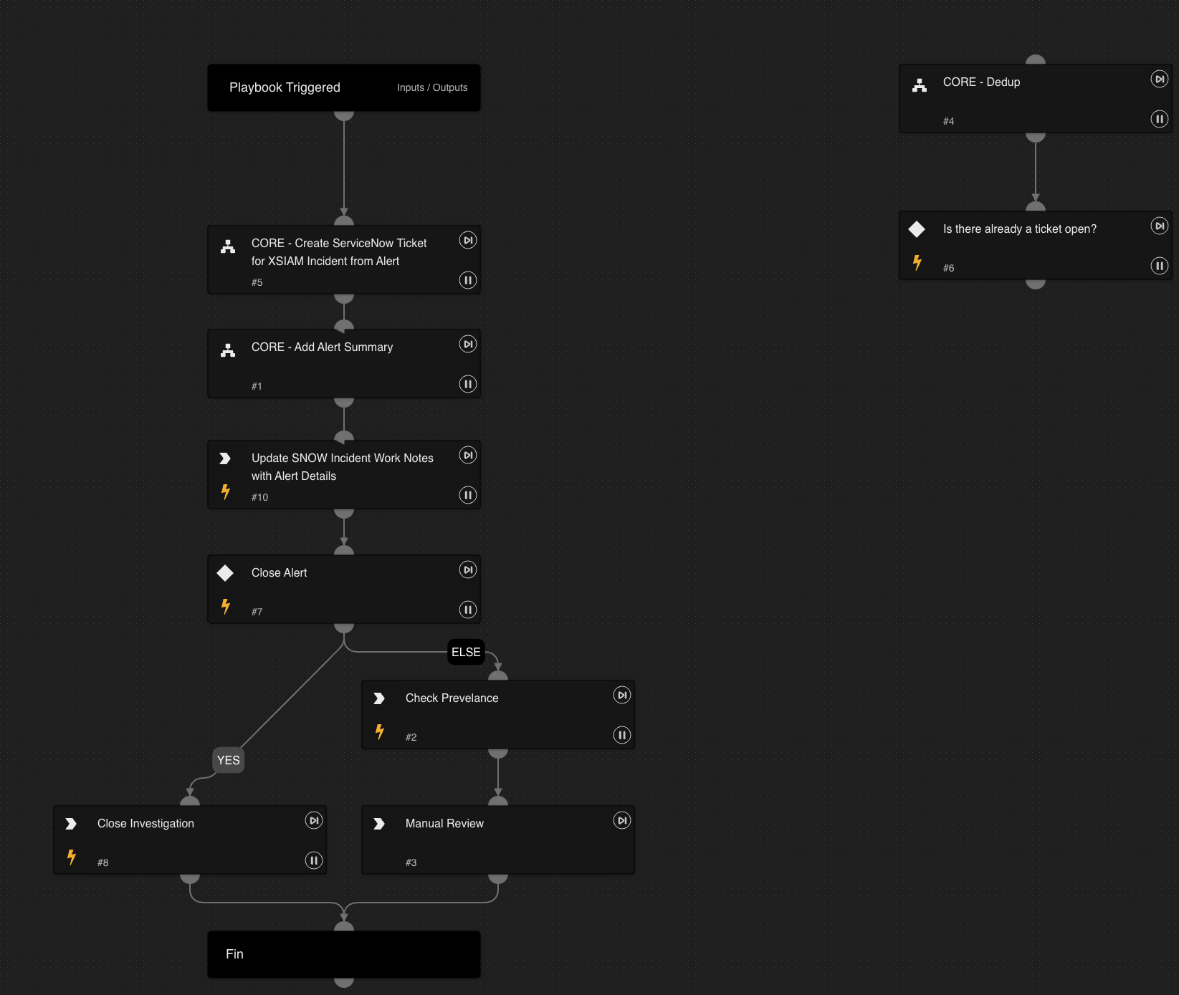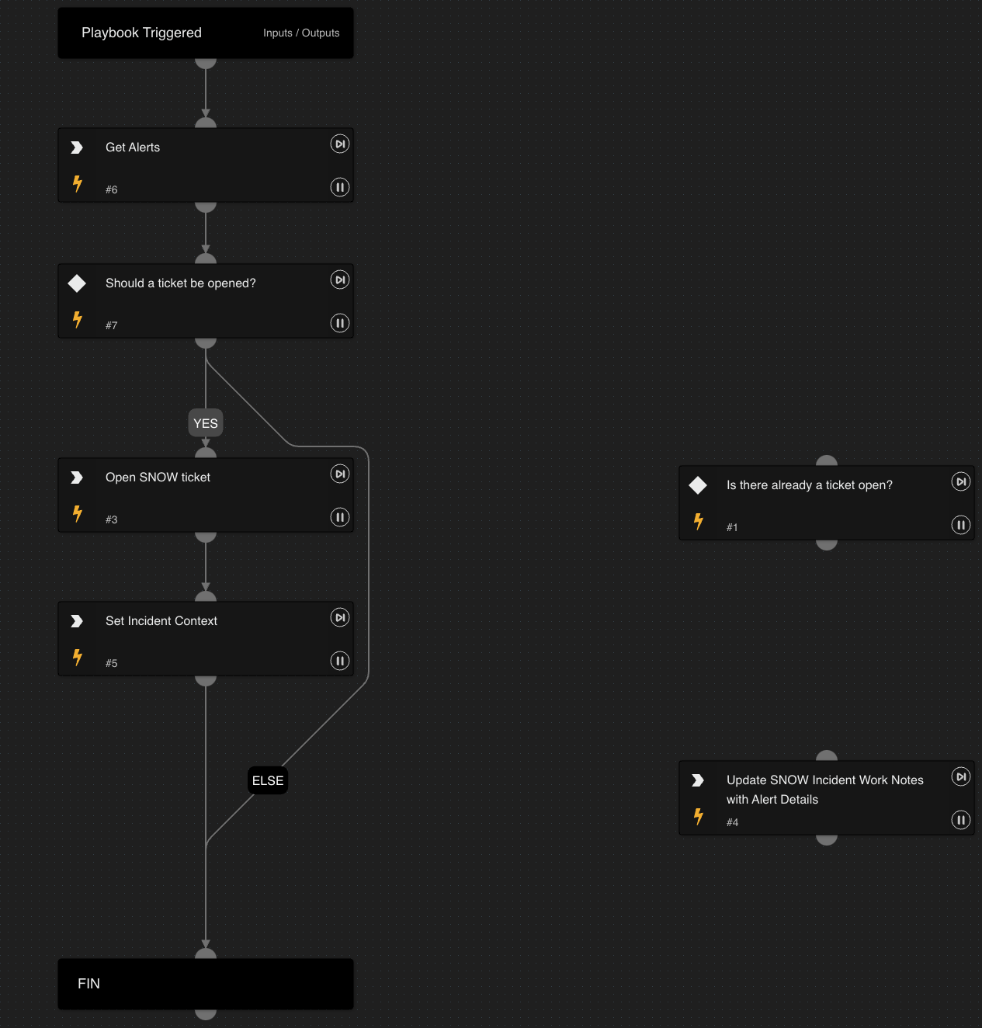

In order to track updates that are made from the ServiceNow incident, it is required to create a new incident field called “xsiam inc id” on each ServiceNow incident. In this way when updates are fetched into XSIAM it is known which XSIAM incident to apply the updates to. This field is then automatically populated by the sample playbooks when the ServiceNow case is created from the first alert.

Attach the “Test - Malicious File Action Playbook” to a sample alert in the XSIAM tenant. It should then create an incident in ServiceNow.

- Add custom incident layout to XSIAM - “ServiceNow Case Management”
- Create incident layout trigger to have it apply to the test incident

It should be possible to momentarily see the ServiceNow ticket details also reflected in the “ServiceNow” tab of the new incident layout. Add a worknote in Servicenow or change a field. After approximately 1 minute the updated values should be pulled in and displayed onto the XSIAM layout. Add a worknote via the button on the XSIAM layout to see it populate in ServiceNow. After a minute it will also populate onto the XSIAM incident layout with complete worknote history as well as any other incident fields

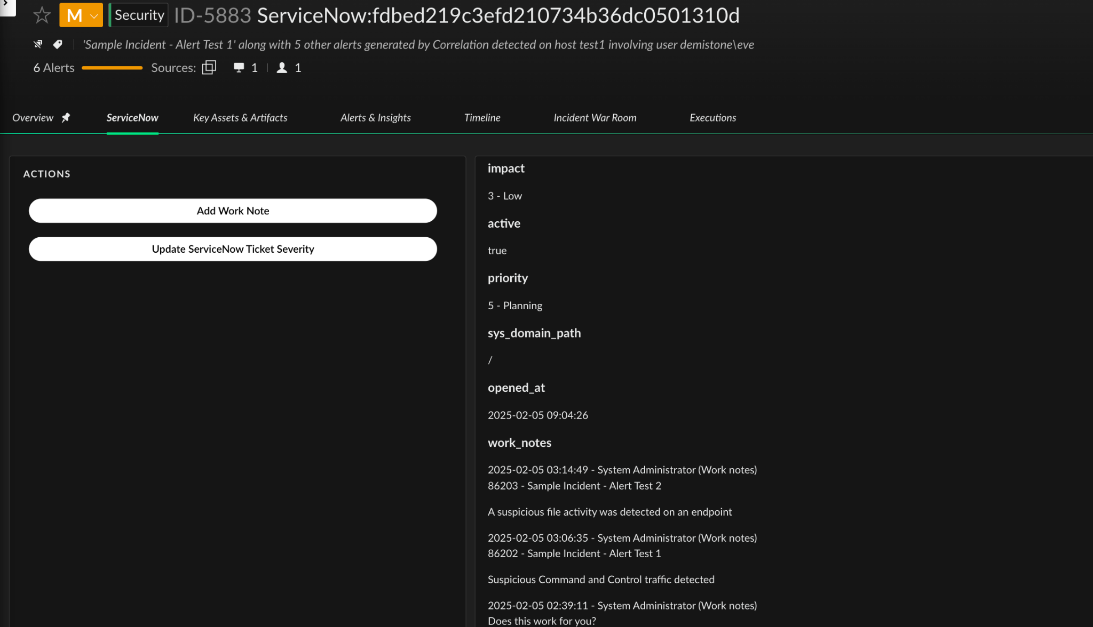

In this way when a ticket is created from XSIAM to SNOW, any update to the SNOW ticket is pulled into XSIAM and updates the corresponding incident since the XSIAM Incident ID is tracked from inception of the SNOW ticket.

Any update from XSIAM to the SNOW ticket would also result in a new pull of the data and subsequent syncing of the data. In short the syncing is bidirectional (with the help of a layout button)

Additional Steps (optional)
If you would also allow for tickets to be created from the ServiceNow side and synced into XSIAM it is possible to have them mapped via correlation rule upon fetching the data in the standard flow. Usually an example correlation rule is automatically generated.

Then use the “ServiceNow based Ticket Handling” example playbook to store the required fields into the XSIAM incident so that updates which occur on the Servicenow side can be synced into XSIAM.

The syncing of war room entries at the incident level can also automatically occur by leveraging the “JOB - Sync XSIAM Incident Work Notes to SNOW”. Set this up to run every minute and it will check for XSIAM cases with status “New”, pull the war room entries tagged with “snow” and add them to the corresponding ServiceNow Case. After they are pushed, the entry tag is updated to be “processed”

Troubleshooting
If there are issues with the integration it may be useful to troubleshoot by attaching the integration instance to an engine which is within your control to monitor. Set the logging level on the integration to “debug”. Then view the integration log file on the engine

sudo tail -f /var/log/demisto/integration-instance.log

Also useful to run the fetch command from the playground with

 !<IntegrationInstanceName>-fetch-incidents


Future Improvements
- Have the “Add work note” button also display the contents of the work note into the incident war room more clearly.
- Create a mapping of close codes between ServiceNow and XSIAM as an input parameter to the integration instead of closing all as “resolved_other”
- Add button to close the ServiceNow case onto the XSIAM incident layout

